ML Model for Anomaly Detection
Revision | Date | Author | Remarks
1.0 | 10 Sep 2026 | Geetha Kodali | V1

Prepared By | Reviewed By | Approved By | Date
Geetha Kodali |  |  | 10 Sep 2026

Table of Contents
Table of Contents 2
1. Purpose and Guidance 3
1.1 Who Should Read This Document 3
1.2 How to Use This Document 3
1.3 Business Significance of “AI/ ML Models for APM functionality” 3
1.4 Solution Approach and the Functional Context 3

1. Purpose and Guidance

1.1 Who Should Read This Document
This document is the single source of truth for building the AI/ML model for Centraa Asset Performance Management (APM). It is written so that a Tech team can build the AI model correctly, and a tester can verify it. The intended readers are:
- Developers building the screens, fields, validations and database changes.
- Testers writing and running test cases.
- Functional consultants to understand the solution scope

1.2 How to Use This Document
Read the sections 1.3 to 1.4 first to understand the business context against which this feature is being developed i.e., what is the business significance of “AI/ML Models for APM”, how this impacts APM solution

1.3 Business Significance of “AI/ ML Models for APM functionality”
AI and machine learning (ML) models are required for Asset Performance Management (APM) because they process massive streams of real-time sensor data or time series data or cyclic equipment data to predict equipment failures before they cause costly breakdowns. AL/ML Models are used primarily in the below areas:
- Anomaly Detection: ML models learn what "normal" machine behaviour looks like and flag real-time deviations or subtle performance drops that human operators might miss.
- Predictive Maintenance (TBD): Algorithms analyse operating patterns, temperature, and vibration data to spot failure signatures weeks or months in advance, replacing reactive repairs with proactive action.

1.4 Solution Approach and the Functional Context
The scope of this document is to train the AI model for Anomaly detections.

Most of the industrial assets produce multivariate, time-series sensor data (such as temperature, pressure, and vibration tracking simultaneously).

Timeseries and trending data (Long-term progression (upward, downward, or stationary)) will work for Rotating Equipment like Pumps, Motors and other steady state machines.

However, Container Terminal Equipment like STS/quay crane or RTG doesn't run at a constant operating point like a pump or fan. Cranes are cyclic and non-stationary. It executes discrete move cycles — spreader down, twist lock, hoist, trolley across, gantry, lower, release — and the load swings from an empty spreader (~10–15 t) to a loaded 40-ft box (~40 t+). Motor current, gearbox temperature, hydraulic pressure and vibration are supposed to vary massively within every cycle, by design.

We should have different AI models that are trained to detect the anomalies of different types of equipment.

In the current SDD, we target to train the AI/ML model on these 2 equipment types - Steady State (Pumps, Fans, Gensets etc) and Cyclic Equipment (RTGs, STS Cranes, QCs etc).

Below data files(xlsx) to be used to train the models.

- Records that are identified as “Healthy” must be used to train the model.
- Records that are identified as “Un-Healthy” must be used to train the model.
- AI team must segregate the data set for training the models.
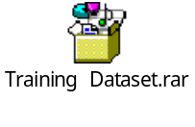

PS: Since AI/ML Model are purely technical in nature, this document must be treated as the functional inputs towards training the model effectively. Technical team to research and decides the algorithms/models that must be used for the mentioned equipment types.

It is recommended to proceed with AI/ML Model training in 2 phases

Phase-1: Proof of Concept (POC)

Train the model on the telemetry data provided in the excel files (Training Dataset.rar).
Expected Output from the AI/ML Model:

QC/RTG/STS/Pump/ Gensets/ Motors etc | Sensor ID against which the timeseries data is captured.  Ex: Gyroscope, Vibration Sensors, Temp Sensors etc | Equipment on which this sensor is installed- QC, RTG etc | Business Entity | Parameter which is monitored via the sensor data  Eg: Temp, Vibrations, Running Hours etc | Date & Time on which this Anomaly is detected first | Parameter Value | In Percentage (95% etc)
Asset Category | Sensor Device ID | Object ID | Site | Parameter Category | Anomaly Start Date/Time | Detected Value | Data Confidence | Detection Outcome

Phase-2: Integrated Solution

- Establish a provision for AI/ML models to read the data from the telemetry Database instead of excel data files.
- Integrate the trained model with CENTRAA APM. Output (Anomalies) from AI/ML model to be pushed to relevant APM screens as mentioned in APM SDDs.

Below is the high-level integrated APM solution view for a holistic understanding.

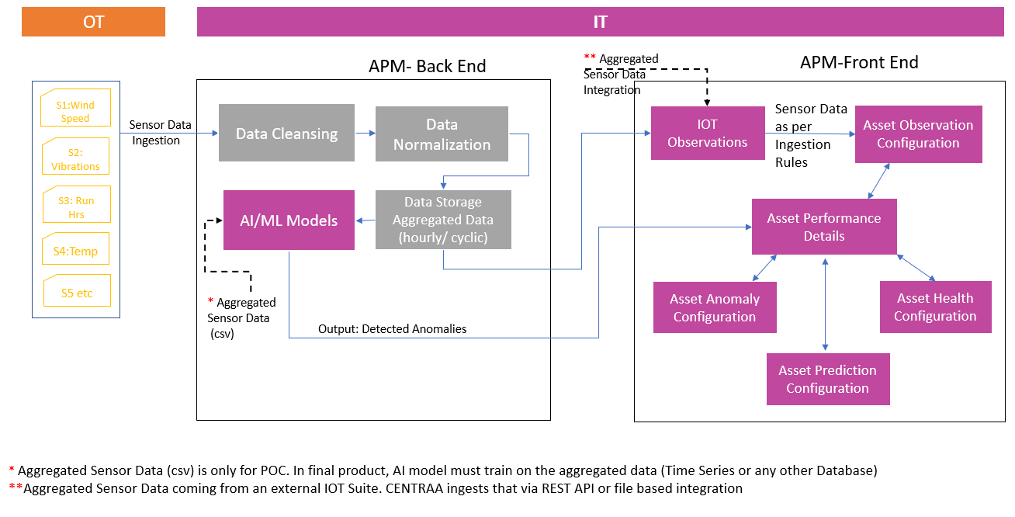
PS: A decision must be taken by Technical team on the IOT data integration capabilities and store it in a database for the AI/ML models to be trained.

